Redesigning a broken healthcare workflow using Automation and/or AI

Persona Chosen: Insurance verification and Claims processing with Denials Management
1. Problem:
Adjacent to this scenario My father had a spinal surgery at kims begumpet Hyderabad in last April the problem which I faced was The lack of connect between the surgery team and the insurance management and claims processing team of the hospital which was a total disarray of miscommunication regarding the charges to which the patient is being charged
- Need of interaction at multiple counters mostly of which could be done from single window
- Forms are manual in this day and age which can be esigned by patients relatives
- Insurance approval is manual and the process is non transparent
- Billing disputes delay discharge of the patient who is tied up in insurance claim
2. Existing system:
- Patient arrives for surgery with preauthorization from insurer that the hospital is on approved list
- Forms are manually filled and forwarded to insurer
- Authorization is last minute and done via calls and emails
- Surgery is done and consumables in the surgery will be added to bill
- Insurance approves the charge or denies it
- This leads to a dispute with a consumer who blames the hospital for the insurance mishap
3. The Solution:
- A single window system
- The forms are esigned and submitted well in advance
- Comparison of the hospitals mou with insurance company and the associated packages and costs included and excluded shown to consumer
- If any extra costs are incurred then consumer gets notified well in advance of discharge
- Real time billing notifications after surgery done both to insurer and consumer
4. Process:
- Patients walks in with all authorization and the hospital single window counter assigns them an id and an internal site which they can submit documents and view status
- All documents are digital and verified by using the Digi locker verification to prevent fraud cases
- Forms submitted from hospital desk to insurer via api eliminating manual email work
- Same forms pushed onto the consumers site for their viewing
- The price and cost associated from the insurance partner is displayed in the site both for hospital further reconciliation and consumer history
- Use automation to suggest best surgical options based on the approval amount from the insurer
- In case of denial give an approximate cost of surgery to the patient via in person consultation
- After surgery add the additional consumables into the surgical bill mentioning and categorizing using n8n or other automation software to classify them out of which are to be billed to insurer in their package and which cannot to provide an overview to the customer

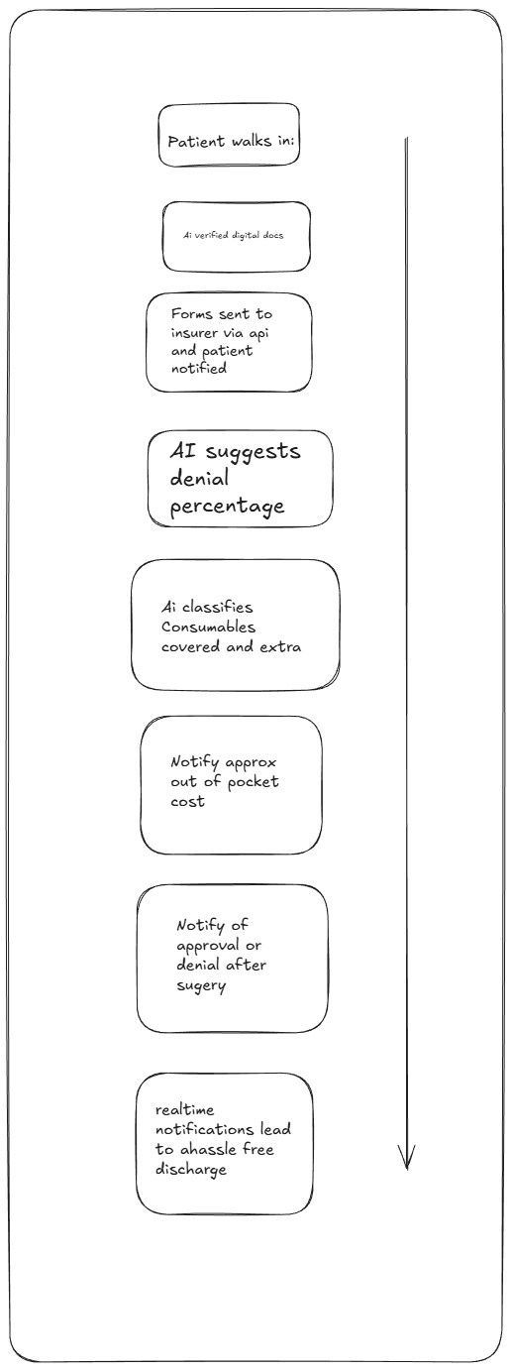
- This allows the hospital to maintain an database of which claims are approved and which are rejected and reasons associated and which insurance companies are approving and rejecting their claims
- This allows the hospital to provide an initial prediction as to if the claim will be processed by the insurance or will it be rejected at a very early stage acting as a early warning to the consumer at the earlier stages alleviating the later stages billing disputes from the hospital
5. Insights:
- Predictive insurance denial or approval before surgery
- Costs associated which are not covered by the insurer for consumer reference
- Improve insurance turnaround time
- Correlation between insurance amount promised and consumer bill generated
- Further data generation for the hospital to analyze insights by data analysis on the various business components involved and their interconnections and draw relevant conclusions
- Better revenue correlation for the hospital in the long run
6. Assumptions made:
- Assumed insurance api’s are available for product flow
- Hospital processes are completely digitized including records
- Patients hold mobiles allowing for digital notifications and updates
7. AI utilization:
- Ai helped me get an idea as to the actual billing workflow
- Utilize ai and machine learning for process automation
- Use for prediction and process automation
- Use for ease of doing business
- Reduces turnaround time
- Reduces human induced mistakes while filling forms or attachments

